**CI/CD Deployment for Springboot Application.**

**Developer Name:** PUTTA SAIKUMAR

This document contains contents for:

* Project Description
* Flow of the Application
* Core concepts used in project
* Conclusions.

**1.Project Description:** Build a CI/CD pipeline to demonstrate continuous deployment and host the application on AWS EC2 instance.

* Step:1 creating a springboot Application
* Step:2 Run it by springboot app and maven build and obtain a war file for the project
* Step:3 Using docker convert the war file into an docker image
* Step:4 after this bulid it in Jenkins.
* Step:5:after this pull it in aws cloud

**2.Application Flow:**

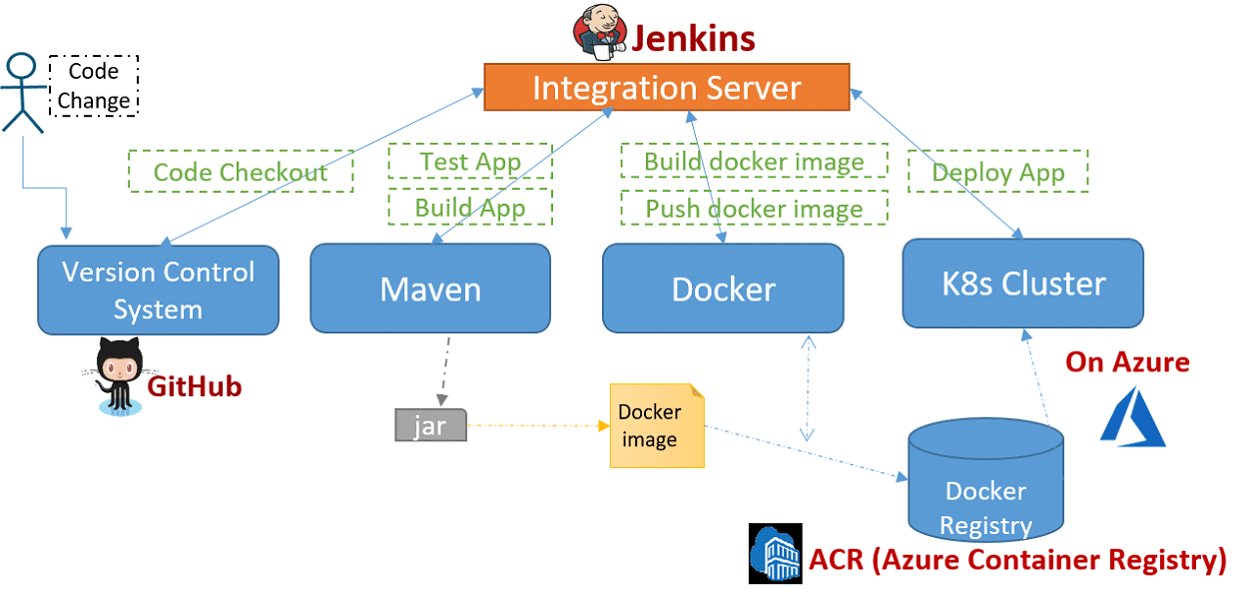

**4.Core concepts used in project:**

* Eclipse
* GitHub
* Jenkins
* AWS EC2/ Virtual machine

Conclusion:

* This project is designed for CI/CD Deployment for Springboot Application.